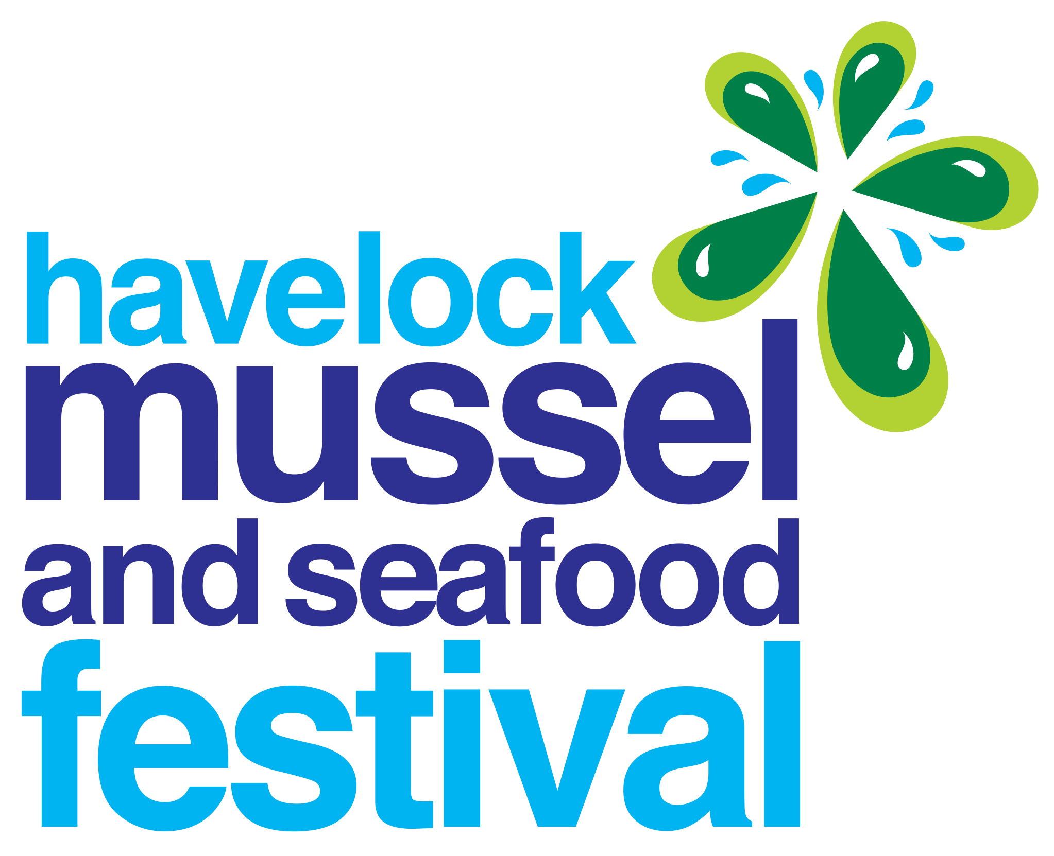**Stall**  **Holder**  **Information**  **& Application**  **Form -** **2026**

**Festival Date:** Saturday 14th March 2026, 10am – 6pm

**Applications close:**  Wednesday 17th December 2025

**Site Set Up for Stalls:** Friday 6th March, 3 pm – 6 pm & Saturday 14th March, 7 am – 9.30 am

**This form must be completed in full even if you have attended this event before. The festival committee reserves the right to refuse entry/ restrict what an exhibitor sells at the festival.**

|  |  |  |  |
| --- | --- | --- | --- |
| **Stall Details – All Stalls are 5m x 5m. When advising the size of your stall, please include the overall length and width, *including* drawbar, and whether your vehicle is part of your stall.**  **Length = Width = Opens Left or Right side (circle)** | | | All prices include GST |
| Relocatable Vehicle on wheels? | | Yes | No |
|  | | **Price** | **Total** |
| Community Group (non-profit) – all profit donated to a community group) | | $65.00 |  |
| Commercial Stall (includes non-GST registered businesses) | | $210.00 |  |
| Industry Marquee (Approved businesses only) Stall is 3m x 3m | | $220.00 |  |
| Electricity (no personal generators allowed) **FRIDAY** night. | | $30.00 |  |
| Electricity (no personal generators allowed) **SATURDAY**  *Full description of POWERED equipment is to be listed below in ADDITIONAL INFORMATION* | | $30.00 |  |
| Extra stall holder wristbands: 3 are supplied with each stall – maximum of 5 EXTRAS ($20.00 each) | | (ea) $20.00 |  |
|  | | **Total Due** |  |
| Please provide a clear description of **ALL** products, services or food dishes - (first time stalls must attach a photo of your stalls and products):  _________________________________________________________________________________________________________________ | | | |
| **ADDITIONAL INFORMATION**:   1. Marlborough District Council Food Licence Number: ____________________________________________ 2. Power Consumption/Requirements: (**Total kw OR amps is required). __________________________________** 3. **Please provide a full description of equipment the power is required for. E.g: coffee machine, fryer, fridge, oven etc, etc.**   **Powered equipment:**  **__________________________________________________________________________________________________________________**   1. If you want to park your stall at the festival grounds on **FRIDAY** night, **PLEASE NOTE** *that to meet health and safety requirements all stalls requiring power overnight on Friday will need to be allocated a site in a central block* ***and*** *will need to operate from there on Saturday.*   ***If you need power overnight, please state what electrical equipment will be plugged in overnight:***  *_______________________________________________________________________________________________________*   1. **PREFERRED SITE ALLOCATION**. Festival organisers will do their best to accommodate your requests but there is no guarantee that requested sites will be allocated. Festival organisers will have the final say on allocation of site.   Preferred site number: 1st choice: 2nd choice: 3rd choice:     1. Food stalls that have gas cooking facilities are to provide fire extinguishers and fire blankets. 2. Does your stall include a contactless payment option; e.g. tap and go Eftpos? Yes/No   Eftpos available, but not contactless | | | |
| Have you included:  Photograph of stall (first-time stallholders)?  Copy of your electrical WOF (relocatable vehicles)? | **DECLARATION:**  We agree to abide with all the terms and conditions set out in the stallholders’ information. **I have read and understood the Health and Safety document displayed** **on the website.** I understand that fees for failing to comply are at the stallholder’s cost.  Signed: ____________________________________ | | |

Once your stall application has been approved by the committee, you will be emailed an invoice to the email address provided. This invoice is due for payment on receipt. Your Contact Details:

Business/Organization Name: _______________________________________________________________

Contact Name:

Phone Number:

Postal Address:

Email Address:

Please return this form to: Havelock Mussel Festival

Email: stalls@havelockmusselfestival.co.nz Ph: 03 574 2558

# INFORMATION SHEET

|  |  |
| --- | --- |
| **FOOD AND DRINK STALLS** |  |

To assist with the overall co-ordination of exhibitors and the festival programme, it is important that you clearly state an accurate list of food/beverages/products which you will be selling. If for any reason this changes before the Festival, please contact the stall organisers ASAP. Any stall selling products on the day without the approval of the stall organisers, risk being closed down.

**The last couple of festivals have seen several food stalls, particularly those selling seafood dishes, run out of product.**

**Please ensure you bring sufficient product with you to avoid crowd disappointment. To assist you in this, we will advise you on the Monday of the preceding week how ticket sales are trending. The most common complaint of the Festival has been how early some stalls sold out of product**.

There are some Marlborough District Council (MDC) conditions that all stallholders must adhere to. These are as follows:

* Sweetened beverages, we encourage and request all food and beverage stall holders to sell sugar free drinks at the festival such as water, fruit drinks with no added sugar, unsweetened milk and sugar free soft drinks.
* Trays or protections are to be laid down by food stalls to prevent grease, fat or harmful materials damaging the grounds.
* All sites selling food &/or beverages must have a food stall licence from the council – this is your responsibility. All licences need to be clearly displayed at your site.
* All food packaging or drink vessels must be disposable, not breakable items. No glass or hard breakable plastic will be allowed on the domain area.

Forms for licences can be downloaded from the MDC website: [www.marlborough.govt.nz or](http://www.marlborough.govt.nz/) phone 03 520 7400 for more information. Please allow plenty of time to submit your form. These forms are to be submitted to the Marlborough District Council at the address on the form, not to the festival Committee or Contractor. Stalls will be inspected by MDC for compliance on the day of the festival and those without the required permit on display or any stalls not complying with the conditions of their permit may be closed down.

All stallholders must only have inspected meat products for sale. Mussels or fish for sale must have been procured through registered fish receivers or be supplied through the official festival supplier (for community groups only – subject to availability).

All sites selling water must be packaged and sealed, due to new licencing.

NO tap water is to be supplied other than by the organisers.

ALL FOOD &/OR DRINK STALLS ARE TO BRING A TABLE AND CHAIRS FOR PATRONS.

|  |  |
| --- | --- |
| **SITE STRUCTURE** |  |

Sites are 5m x 5m. Please ensure all your equipment, including your vehicle (where relevant) is contained within this area. This space is not negotiable and if you take up more space on the day we will need to ask you to move your goods and/or marquee. **When advising the size of stall, please include the overall length and width, including draw-bar, and whether your vehicle is part of your stall.**

All sites are bare and un-powered, unless otherwise booked on the stall holder application form. Stall holders will need to provide protection from the elements, gas powered cooking equipment, food storage and presentation areas. It is recommended that on-site food preparation be kept to a minimum.

For additional equipment hire contact: Continental Tel 0800 252 555, McKendrick Event Hire 021 504 074 or Blenheim Hirepool Tel 03 578 1111. These companies all have a wide range of equipment for hire.

|  |  |
| --- | --- |
| **SET UP** |  |

The festival site will be open for setting up on Friday 6th March, between 3pm and 6pm (you will be required to leave the festival site by 6.30pm).

It will re-open from 7am on the day of the festival.

Please take note of these times – there will be no access outside of these times.

Sites must be set up by 9.30am on the day of the festival and ready for opening at 10.00am. All vehicles not remaining within the boundaries of your 5m x 5m site must be removed from the domain by 9.30am. These vehicles will not be allowed back on site until after the finish of event (approx. 6.15pm).

Stallholder access to the site will be from the Peel Street (off Cook Street) entrance only.

Stallholders must wear their stallholder wristbands. Security will be checking these at the gate and will remove and re-issue wristbands if they are not secured properly. You will not be allowed entry without them. Stallholders must arrange their own parking outside the festival boundary.

NO WRISTBAND, NO ENTRY – NO EXCEPTIONS

Sites must remain set up until the finish of the entertainment at approx. 6.00pm.

|  |  |
| --- | --- |
| **ALCOHOL STALLS** |  |

Only stalls designated by the organisers are permitted to sell alcohol. ***All alcohol stalls must apply*** ***for their own special liquor license, which will be at your cost.*** You must always provide at least one person with a current bar managers license and must hold and display your Liquor License to trade at the event, for the specific date.

Alcohol sales must end at 5.30pm.

Alcohol stalls are responsible for checking ID for all customers under 25 and monitoring intoxicated customers. If any help is required during the day with difficult people, please contact onsite police or roving security. Any fines incurred because of irresponsible management of Alcohol sales will be the responsibility of the stall holder.

There are alcohol check points in place operated by the police at departure points of the festival. There is to be no bottle sales or sales of alcohol in glass containers. Remember the festival is being held on a children’s playing field. Any non-compliance of this rule risks your future involvement in the festival.

**HEALTH & SAFETY**

All sites must have their own Health & Safety Polices that comply with Health & Safety legislation and make themselves familiar with the HMSF Health and Safety Policies displayed on the website, havelockmusselfestival.co.nz

All sites operating gas or electrics must have a fire extinguisher on site, this is on the advice of Marlborough Fire Safety, and to help protect you from not only your own potential fire, but that of a neighbouring site. Please ensure all your staff know where it is and how to use it. Small extinguishers are available to hire through Fire Safety Systems Tel 0508 352 637. Please note food stalls will be inspected for these. If you are operating by Gas, please have a bottle of soapy water available to check for gas leaks, this is a requirement of the fire safety officer.

Stallholders may close their stalls earlier and carry equipment off site, but tents/marquees etc. cannot be removed until the end of the festival.

Absolutely no cars are to be driven around the site between 9.30am & 6pm – this is in the interest of public safety.

|  |  |
| --- | --- |
| **RUBBISH** |  |

Stallholders are responsible for removing their own rubbish from their site throughout the day and during pack up. The festival provides wheelie bins & skips for public use – please do not fill these up with stallholder rubbish!! **It is your responsibility to take your rubbish away with you.**

|  |  |
| --- | --- |
| **JUDGING** |  |

Please take pride in setting up your stall, as they will be judged early in the day. The winners are announced on the day and displayed on the Havelock Mussel Festival website.

Categories are:

* Best Commercial Stall Holder
* Best Community Stall Holder
* Best Seafood Creation
* Best Mussel Dish of the Festival

|  |  |
| --- | --- |
| **WRISTBANDS** |  |

If you require more wristbands than your allocation of three, please fill in the appropriate section on the Stall Application form. Please note you are entitled to a maximum of five additional wristbands at the reduced price of $20 per pass. Security Staff have been instructed not to allow anyone without a stall holder or sponsor wristband onto the site before 10.00am so please consider this when planning the set-up of your stall. (Anyone helping you who has purchased a general admission ticket will not be allowed into the site before 10am).

|  |  |
| --- | --- |
| **CURRENCY** |  |

There is no “Festival” currency. PLEASE BRING PLENTY OF CHANGE FOR YOUR OWN STALL. You are responsible for your cash takings on the day. You cannot use the Mussel Festival bank at the end of the event to deposit your money or as facility for more change throughout the day.

We highly recommend that you include an Eftpos option on your stall and due to Covid-19, we would recommend even more highly that this is a contactless payment option.

|  |  |
| --- | --- |
| **SITE SECURITY** |  |

Security will be on site in the fenced off area overnight on Friday.

The main site will be ring fenced from Friday morning and access will only be available at the Peel Street entrance.

Even though the area will be patrolled, it is recommended that where possible, stallholders remove valuable items overnight. Security is based on an all care, no responsibility basis.

The Mussel Festival is not responsible for the loss or damage to any of the stallholders’ products or equipment.

|  |  |
| --- | --- |
| **POWER REQUIREMENTS** |  |

You must include any requirements for power on the Friday night on your application and state what appliance this power is for. There will be an additional charge of $30.00 for Friday night, in addition to the charge of $30 for Saturday. All stalls requiring Friday night power will be sited together in a block for the duration of the Festival.

**NOTE: YOU ARE REQUIRED TO PROVIDE YOUR OWN EXTENSION CORDS & LEADS**

|  |  |  |
| --- | --- | --- |
|  | **ADDITIONAL INFORMATION** |  |

A water tap is available on the seaward side of the domain. This is for everyone’s use, and permanent hoses must not be connected to this water supply.

Any stall holder who is found to be responsible for damage to the festival site in any way that requires maintenance e.g. burnt grass, water damage, etc. will be liable for costs and/or repair. This will be dealt with by the Marlborough District Council and is not the responsibility of the organisers. You are to leave your site in the condition in which you found it.

**ABSOLUTELY NO DOGS ALLOWED AT THE FESTIVAL.**

|  |  |
| --- | --- |
| **Documents attached** |  |

1. Site Plan
2. HMF Health and Safety Plan as relates to stall holders.

**CONTACT DETAILS**

Havelock Mussel Festival

Phone: 03 574 2558

Email: stalls@havelockmusselfestival.co.nz